Plane-Region Generator

Definition
# Source: AI Source: Provided by: [Data Path: Persons Table -> ID Column: 1, Name_En Column: Motasem Essam] -> From: [ChatGPT] on [7/25/2026]
A Plane-Region Generator (also called a Generating Region or Generating Lamina) is a two-dimensional geometric region that moves through three-dimensional space according to a specified geometric rule to generate a three-dimensional solid.
Unlike a straight-line generator or a curved-line generator, which produces a surface, a plane-region generator produces a volume when its movement sweeps out a three-dimensional region.
A plane region can generate a solid through different types of motion, including:
- Rotation: The region rotates around a fixed axis, generating a solid of revolution.
- Translation: The region moves along a specified direction, generating an extruded solid.
- Combined Motion: The region undergoes more than one type of movement, generating a swept solid.
Examples include a rectangle generating a cylinder, a right triangle generating a cone, and a semicircular region generating a sphere when rotated around appropriate axes.

Geometric Representation
# Source: AI Source: Provided by: [Data Path: Persons Table -> ID Column: 1, Name_En Column: Motasem Essam] -> From: [ChatGPT] on [7/25/2026]
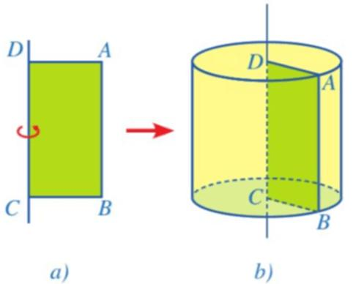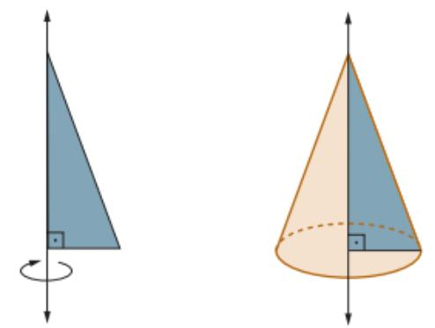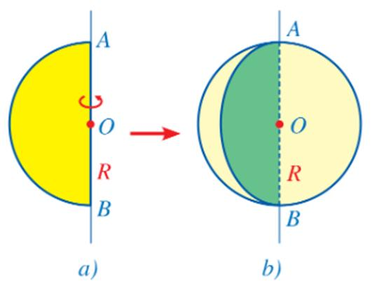

Geometric Structure
# Source: AI Source: Provided by: [Data Path: Persons Table -> ID Column: 1, Name_En Column: Motasem Essam] -> From: [ChatGPT] on [7/25/2026]
A plane-region generator has the following characteristics:
- Two-Dimensional Form: The generating element is a plane region with area.
- Continuous Motion: It moves according to a defined geometric rule.
- Generating Boundary: Its boundary determines the shape and limits of the generated solid.
- Motion Direction: It may rotate, translate, or undergo combined motion.
- Volume Formation: Its successive positions sweep out a three-dimensional region.
- Solid Formation: The resulting volume may be bounded by curved surfaces, flat faces, or both.

Fundamental Elements
# Source: AI Source: Provided by: [Data Path: Persons Table -> ID Column: 1, Name_En Column: Motasem Essam] -> From: [ChatGPT] on [7/25/2026]
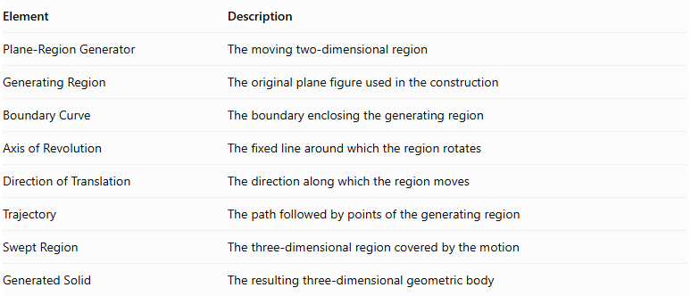
Element | Description
Plane-Region Generator | The moving two-dimensional region
Generating Region | The original plane figure used in the construction
Boundary Curve | The boundary enclosing the generating region
Axis of Revolution | The fixed line around which the region rotates
Direction of Translation | The direction along which the region moves
Trajectory | The path followed by points of the generating region
Swept Region | The three-dimensional region covered by the motion
Generated Solid | The resulting three-dimensional geometric body

Types of Plane-Region Generators
# Source: AI Source: Provided by: [Data Path: Persons Table -> ID Column: 1, Name_En Column: Motasem Essam] -> From: [ChatGPT] on [7/25/2026]
Plane-region generators can be classified according to their geometric shapes and the type of motion used to generate solids.

Rectangular-Region Generator
# Source: AI Source: Provided by: [Data Path: Persons Table -> ID Column: 1, Name_En Column: Motasem Essam] -> From: [ChatGPT] on [7/25/2026]
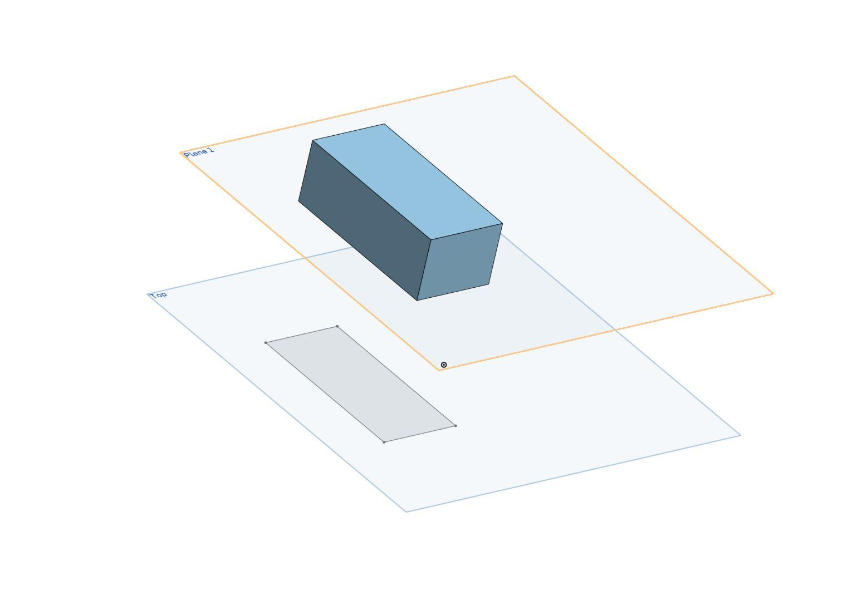
A Rectangular-Region Generator uses a rectangular plane region to generate a solid through rotation or translation.
Examples:
- Cylindrical Solid Generator: Rotating a rectangle around one of its sides generates a cylinder.
- Rectangular Prism Generator: Translating a rectangle in a direction perpendicular to its plane generates a rectangular prism.

Triangular-Region Generator
# Source: AI Source: Provided by: [Data Path: Persons Table -> ID Column: 1, Name_En Column: Motasem Essam] -> From: [ChatGPT] on [7/25/2026]
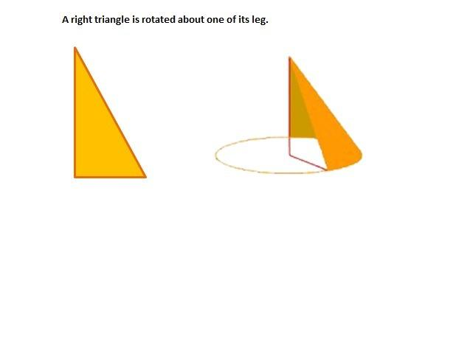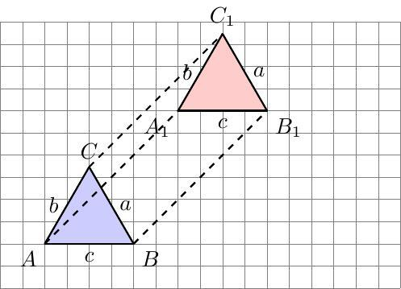
A Triangular-Region Generator uses a triangular plane region to generate a solid.
Examples:
- Conical Solid Generator: Rotating a right triangle around one of its perpendicular sides generates a right circular cone.
- Triangular Prism Generator: Translating a triangle in a direction perpendicular to its plane generates a triangular prism.

Circular-Region Generator
# Source: AI Source: Provided by: [Data Path: Persons Table -> ID Column: 1, Name_En Column: Motasem Essam] -> From: [ChatGPT] on [7/25/2026]
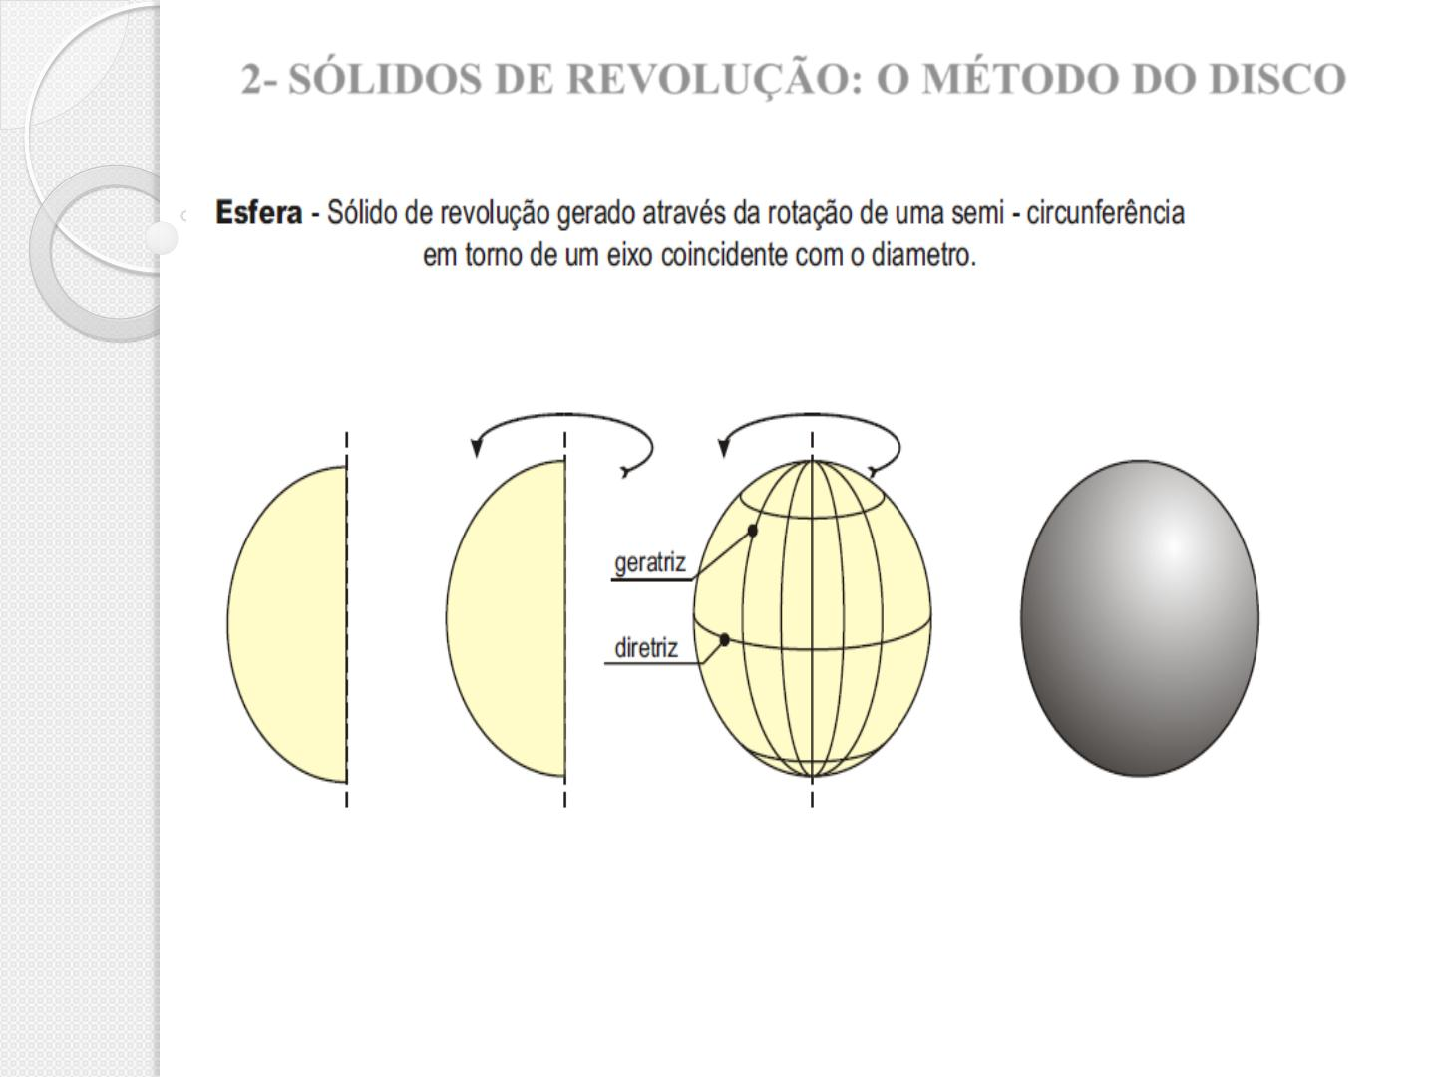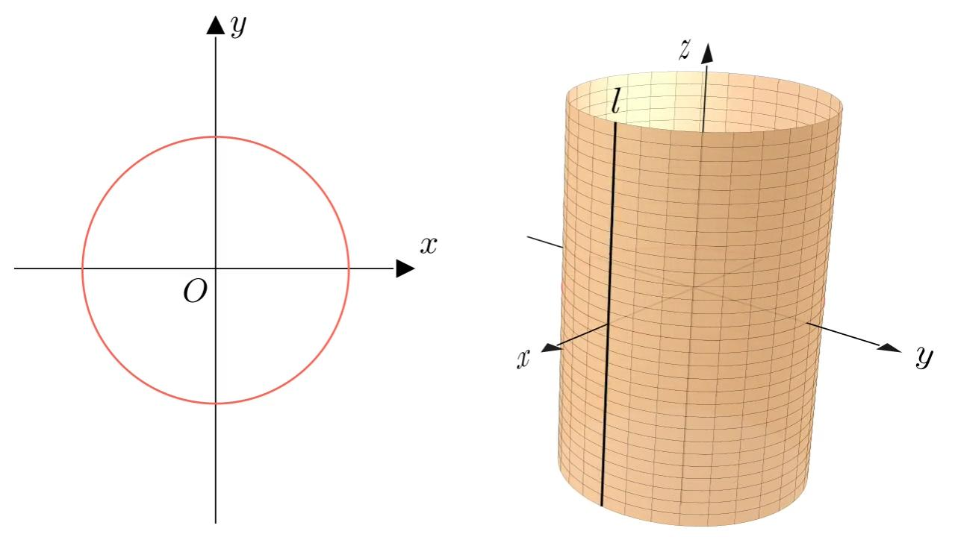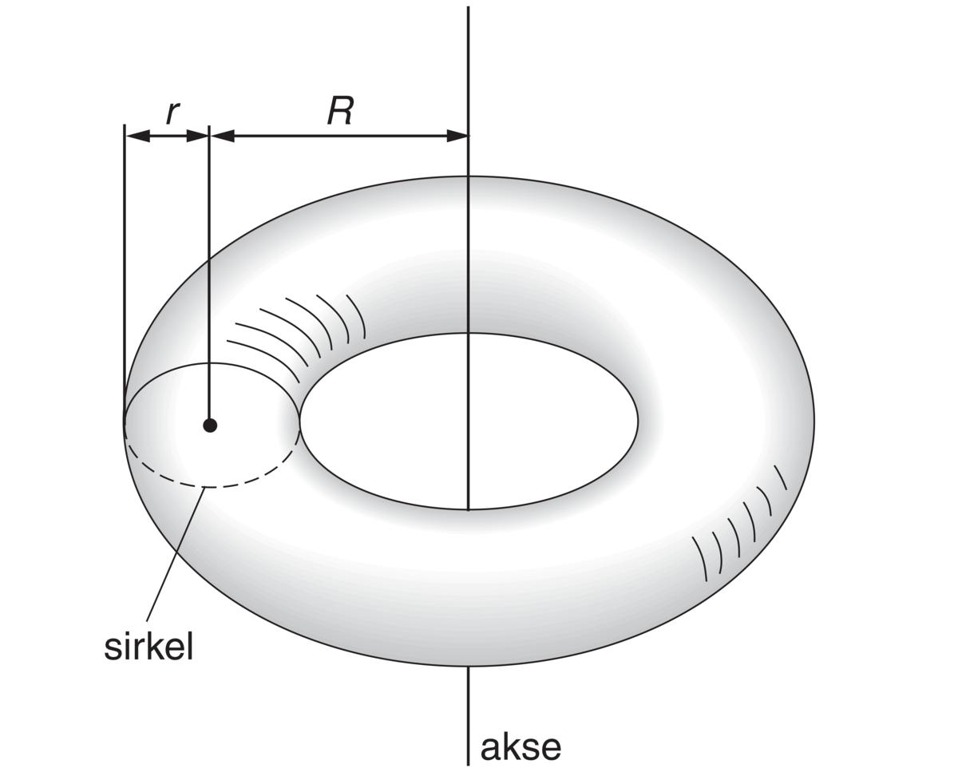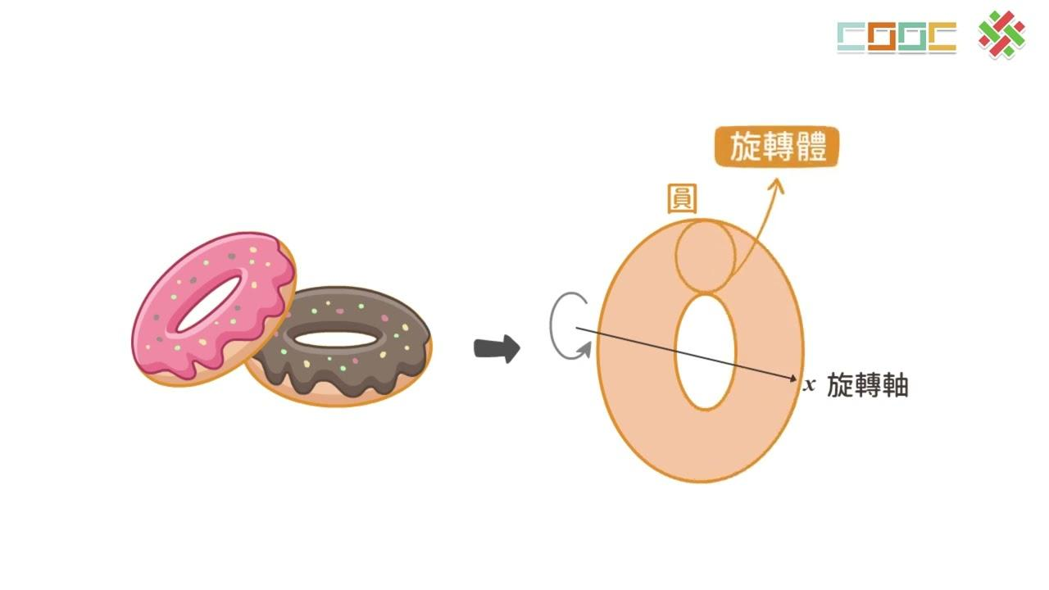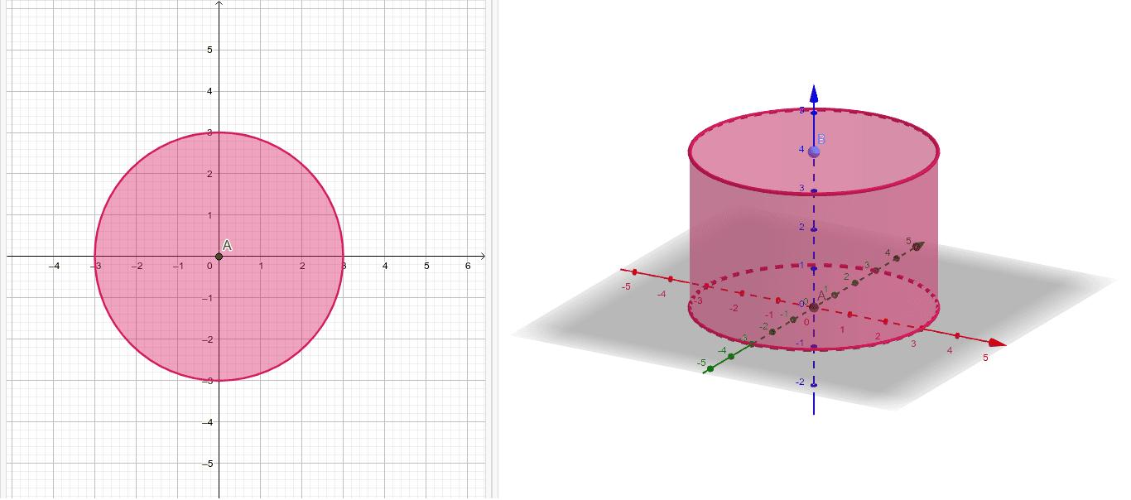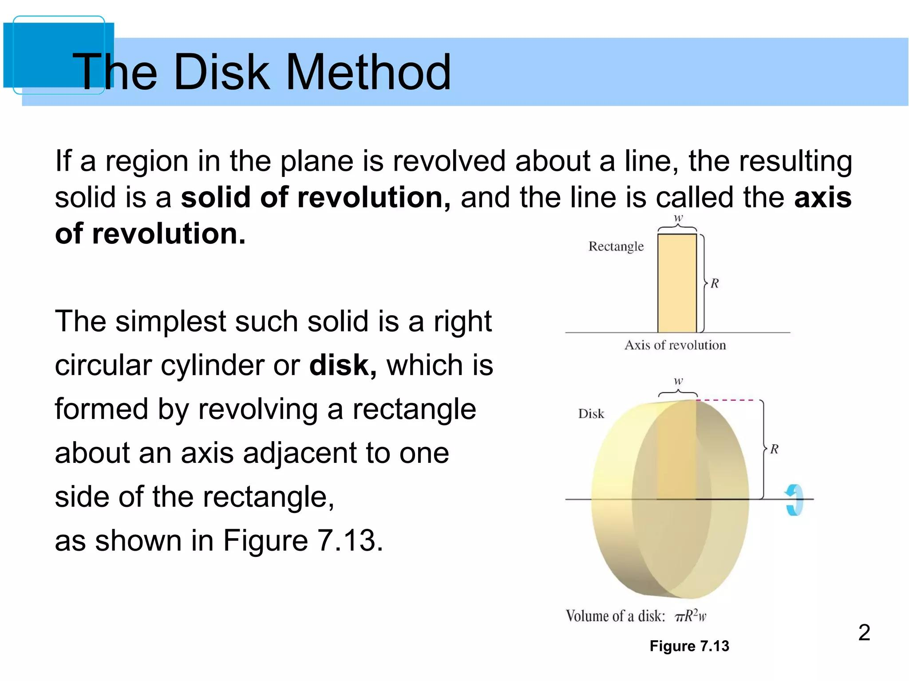
A Circular-Region Generator uses a circular disk to generate a solid through rotation or translation.
Examples:
- Spherical Solid Generator: Rotating a circular disk around one of its diameters generates a sphere.
- Cylindrical Solid Generator: Translating a circular disk perpendicular to its plane generates a cylinder.
- Toroidal Solid Generator: Rotating a circular disk around an external coplanar axis generates a toroidal solid, provided the disk does not intersect the axis.

Semicircular-Region Generator
# Source: AI Source: Provided by: [Data Path: Persons Table -> ID Column: 1, Name_En Column: Motasem Essam] -> From: [ChatGPT] on [7/25/2026]
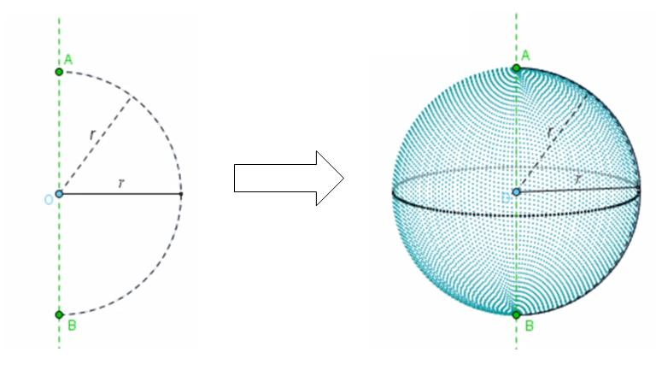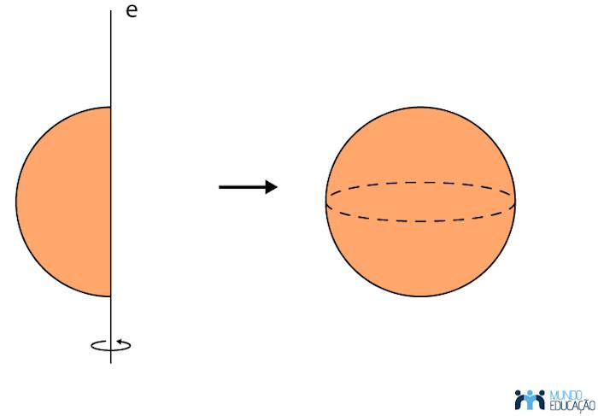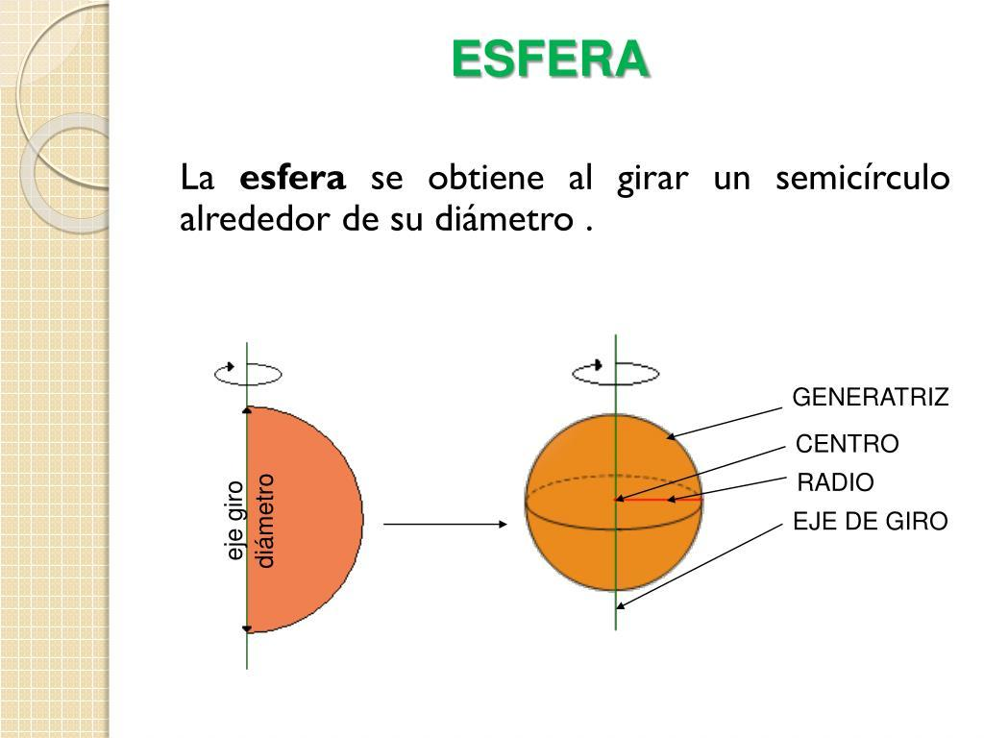
A Semicircular-Region Generator uses a semicircular plane region to generate a solid.
When a semicircular region rotates around its diameter, it generates a sphere.
Other partial rotations can generate portions of a spherical solid.

Elliptical-Region Generator
# Source: AI Source: Provided by: [Data Path: Persons Table -> ID Column: 1, Name_En Column: Motasem Essam] -> From: [ChatGPT] on [7/25/2026]
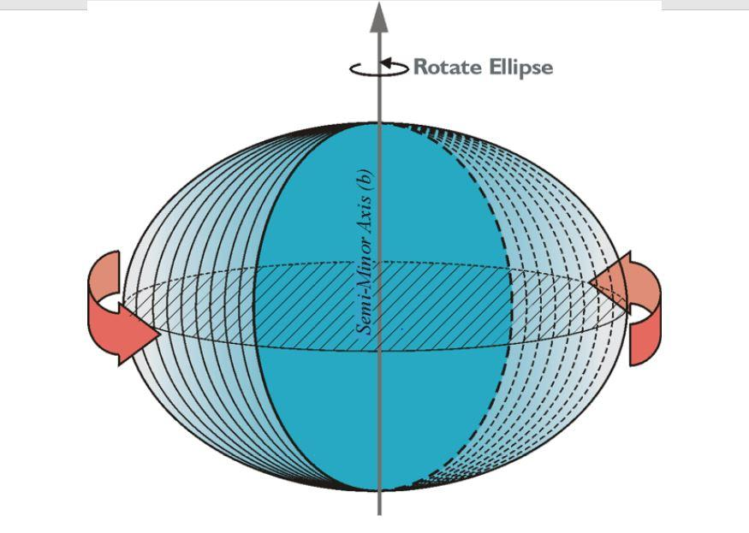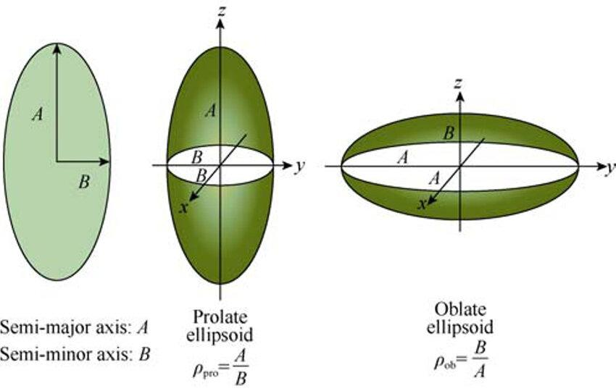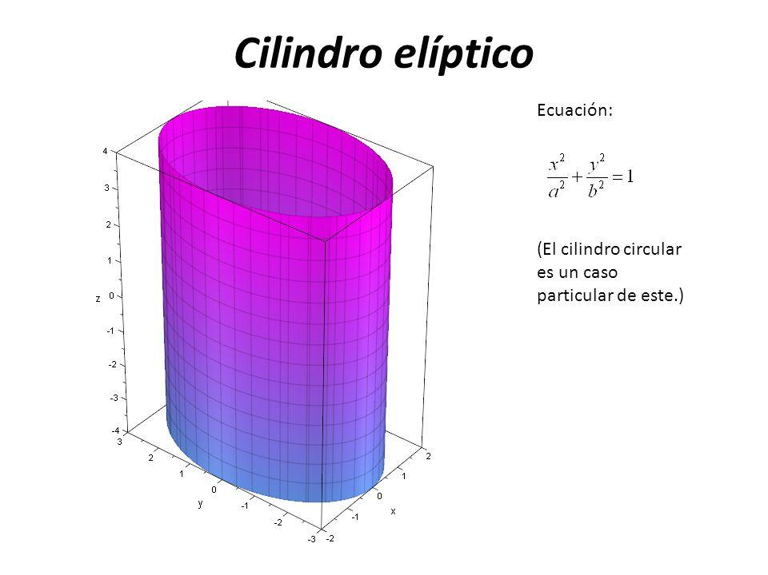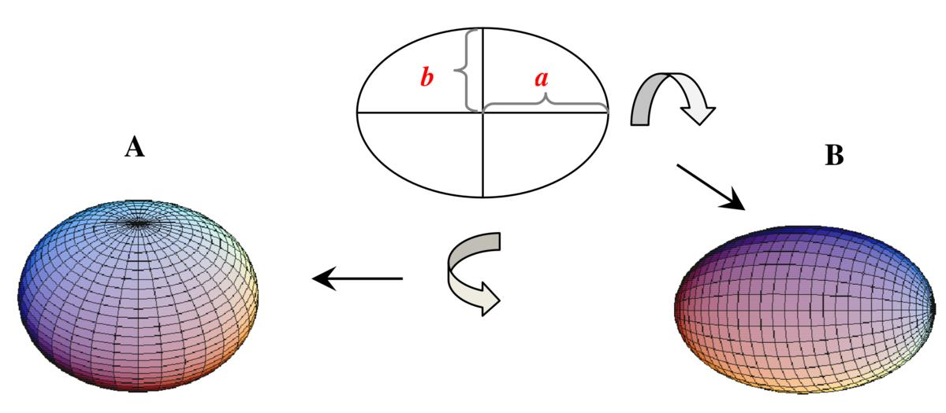
An Elliptical-Region Generator uses an elliptical plane region to generate a solid.
Examples:
- Prolate Spheroid Generator: Rotating an elliptical region around its major axis generates an elongated spheroid.
- Oblate Spheroid Generator: Rotating an elliptical region around its minor axis generates a flattened spheroid.
- Elliptical Cylinder Generator: Translating an elliptical region perpendicular to its plane generates an elliptical cylinder.

Polygonal-Region Generator
# Source: AI Source: Provided by: [Data Path: Persons Table -> ID Column: 1, Name_En Column: Motasem Essam] -> From: [ChatGPT] on [7/25/2026]
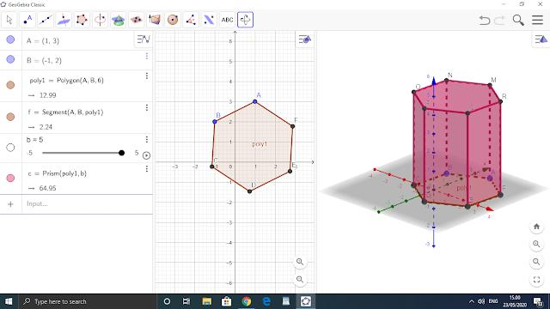
A Polygonal-Region Generator uses a polygonal plane region to generate a solid.
Examples:
- Prism Generator: Translating a polygon perpendicular to its plane generates a prism.
- Regular Polygonal Solid of Revolution: Rotating a suitable polygonal region around an axis generates a rotational solid with a boundary determined by the polygon's geometry.
- Composite Polygonal Generator: Using a region formed by multiple connected polygons to generate a composite solid.

Irregular-Region Generator
# Source: AI Source: Provided by: [Data Path: Persons Table -> ID Column: 1, Name_En Column: Motasem Essam] -> From: [ChatGPT] on [7/25/2026]
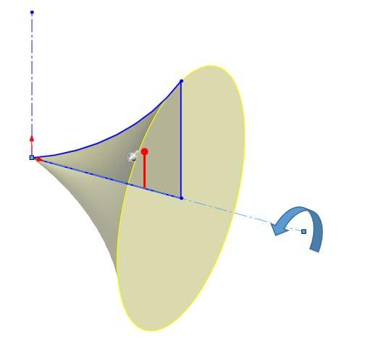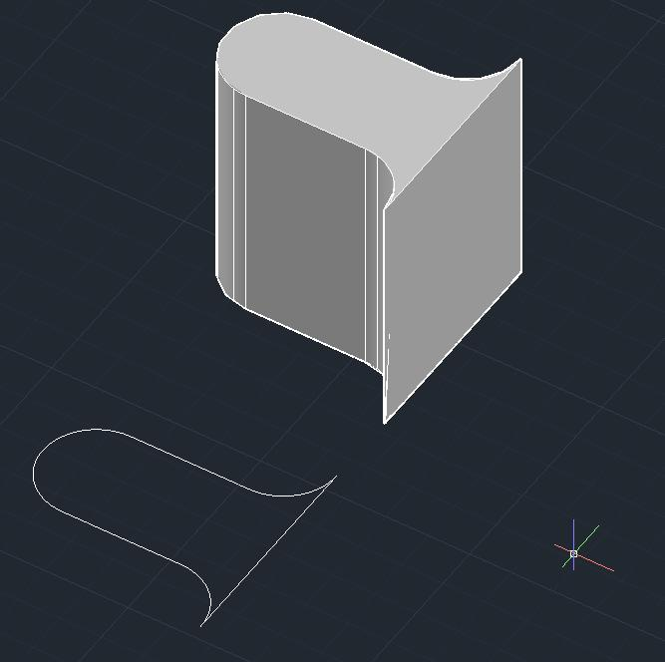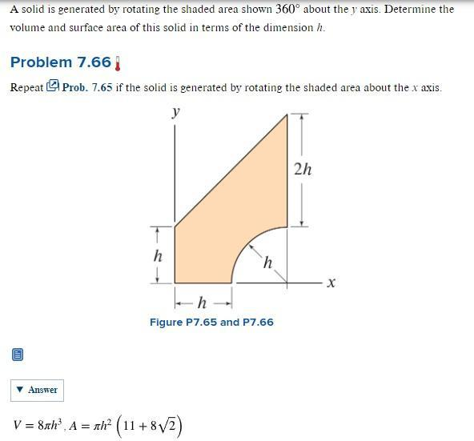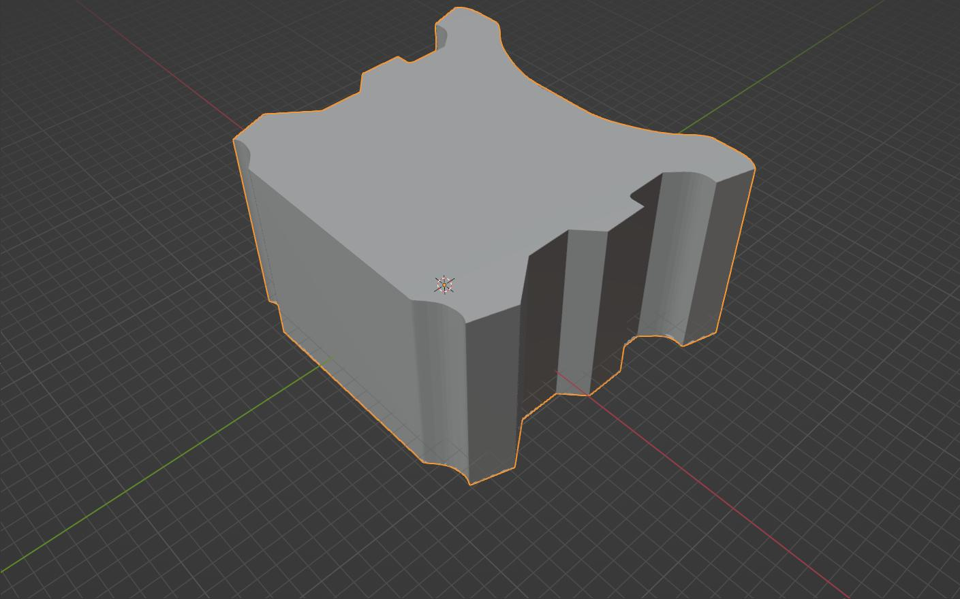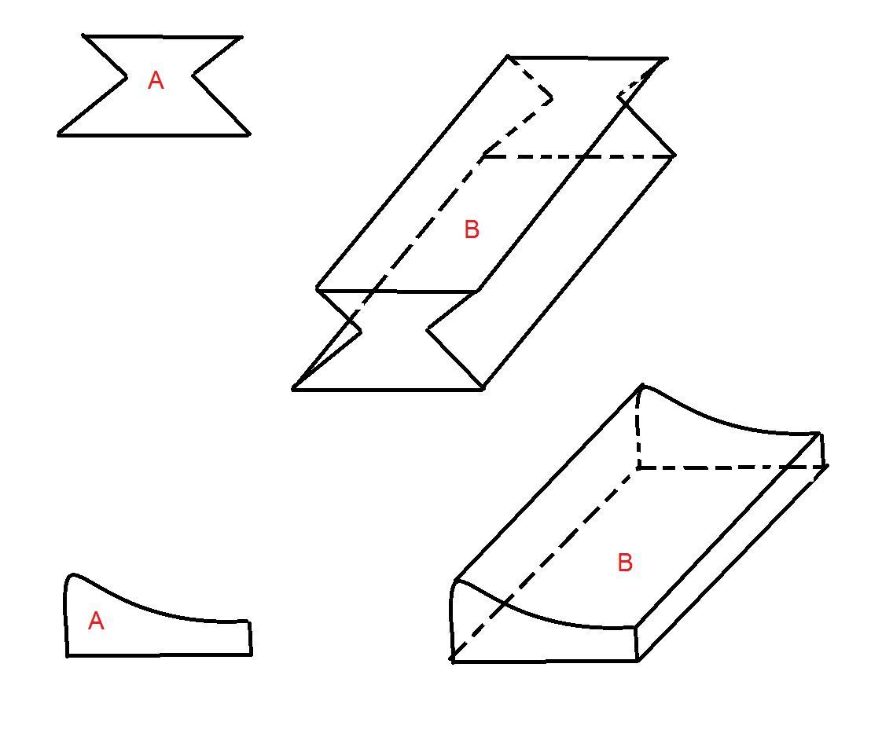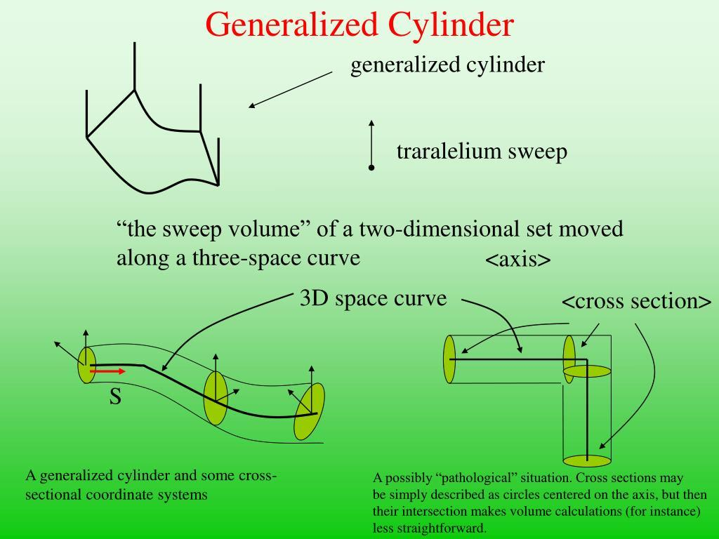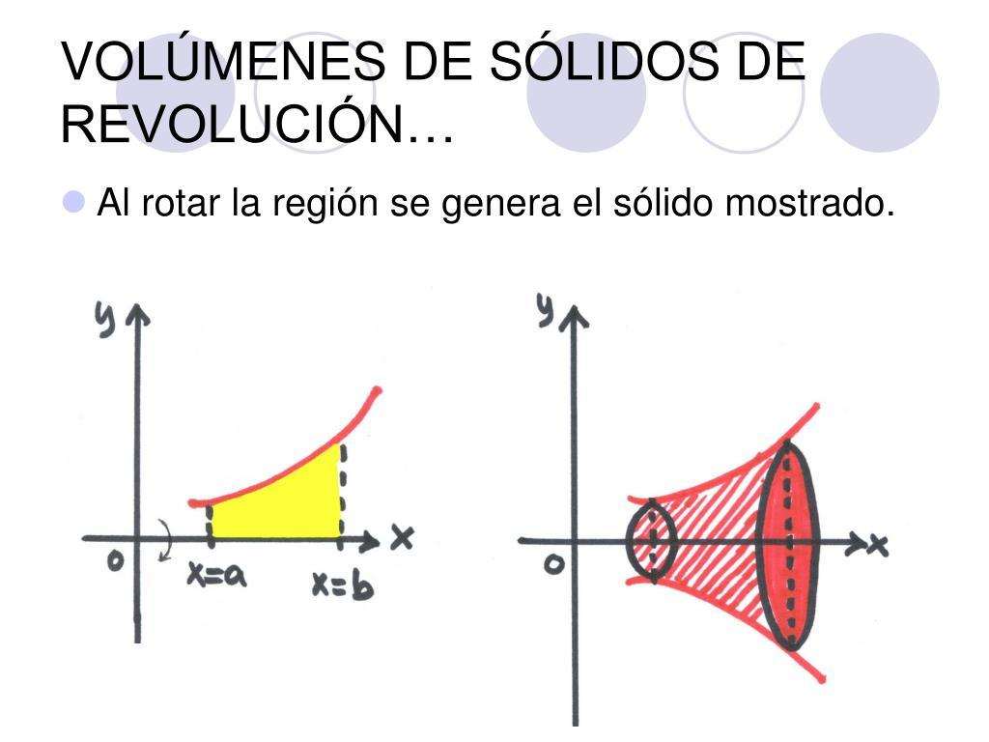
An Irregular-Region Generator uses a plane region that does not necessarily have a standard geometric shape.
Examples:
- Irregular Extruded Solid Generator: Translating an irregular region produces an extruded solid.
- Irregular Solid of Revolution Generator: Rotating an irregular plane region around a fixed axis produces an irregular solid of revolution.
- Composite Solid Generator: Moving a region composed of several different geometric shapes generates a composite solid.

Classification According to Motion

Rotational Plane-Region Generator
# Source: AI Source: Provided by: [Data Path: Persons Table -> ID Column: 1, Name_En Column: Motasem Essam] -> From: [ChatGPT] on [7/25/2026]
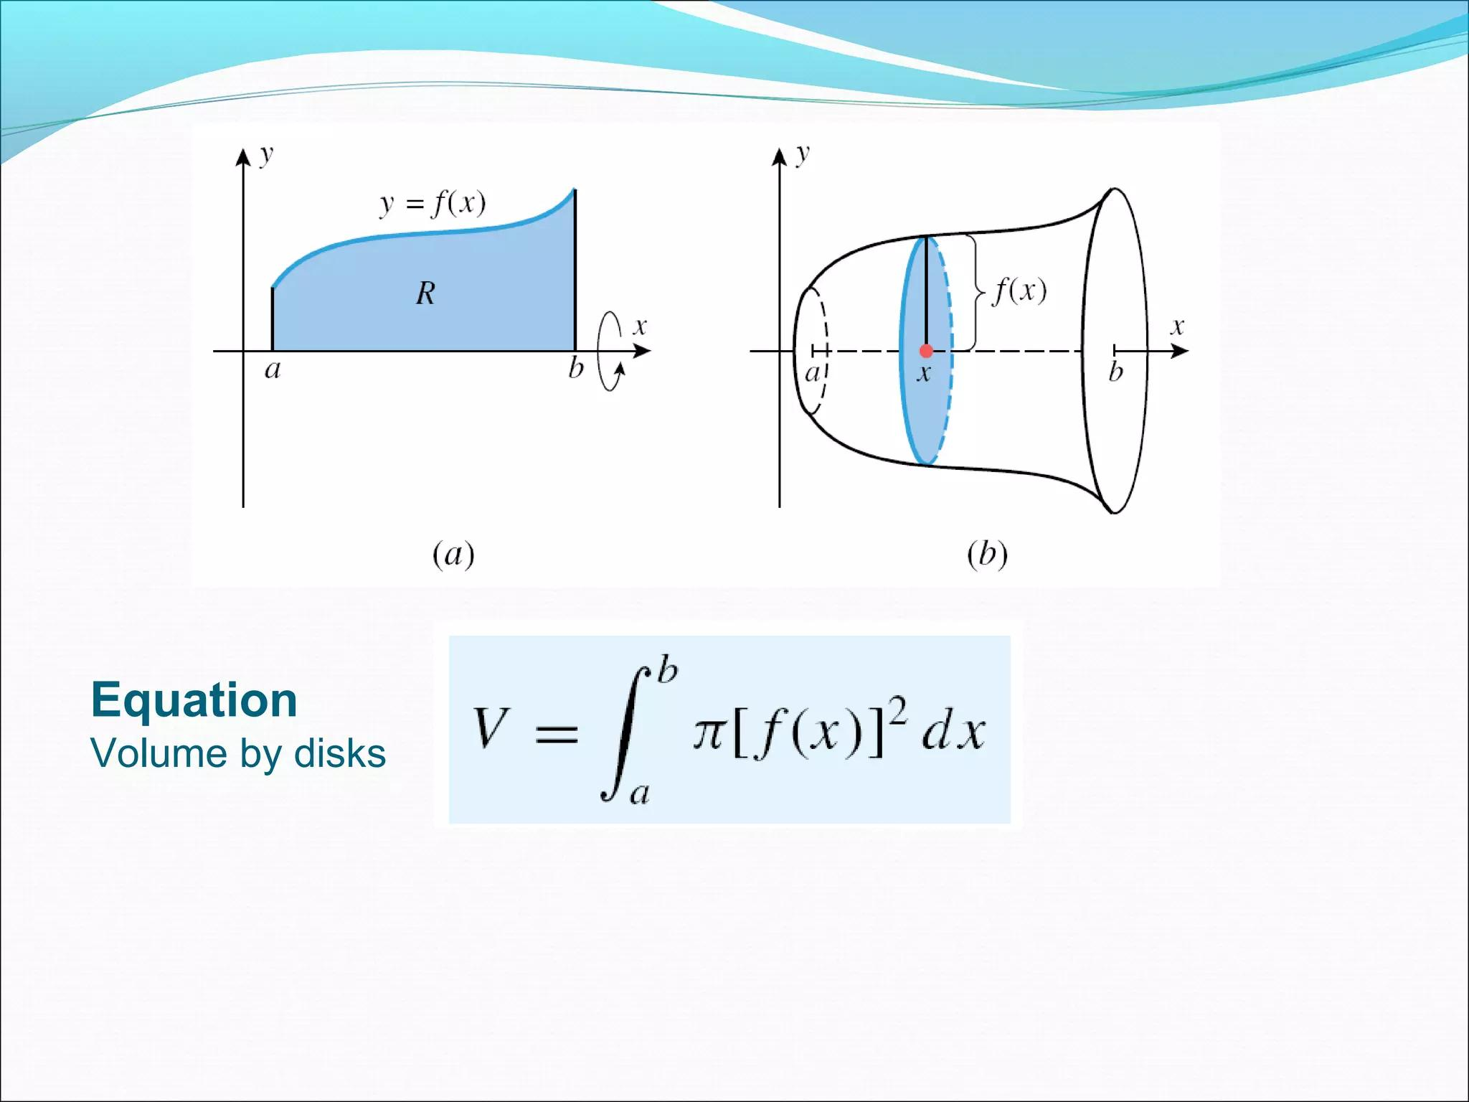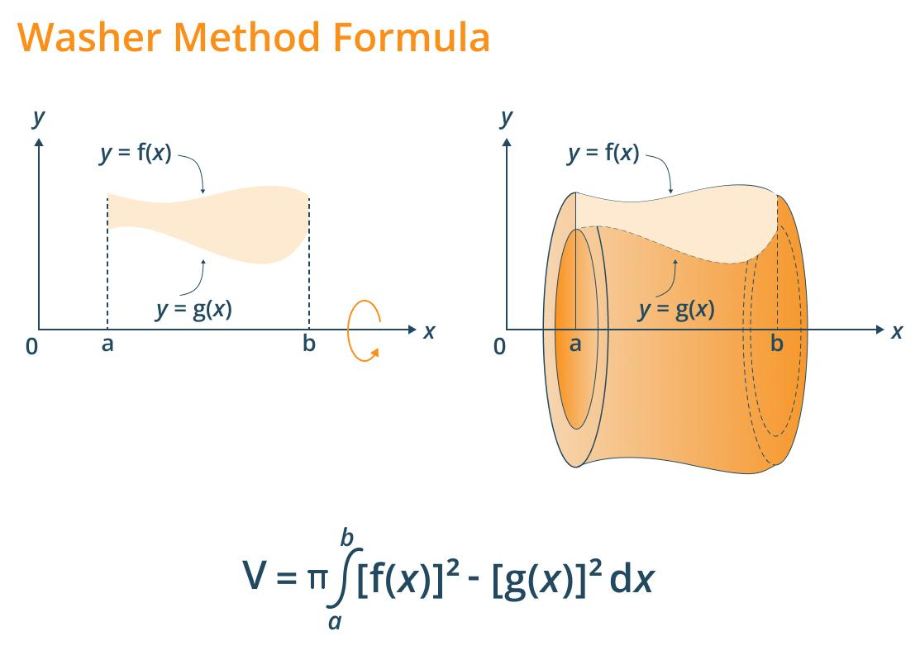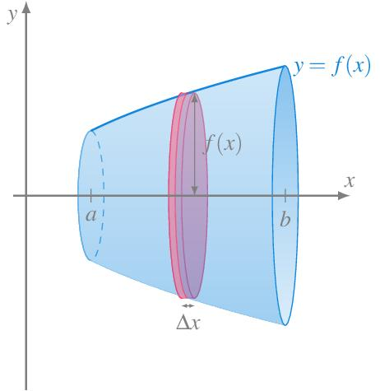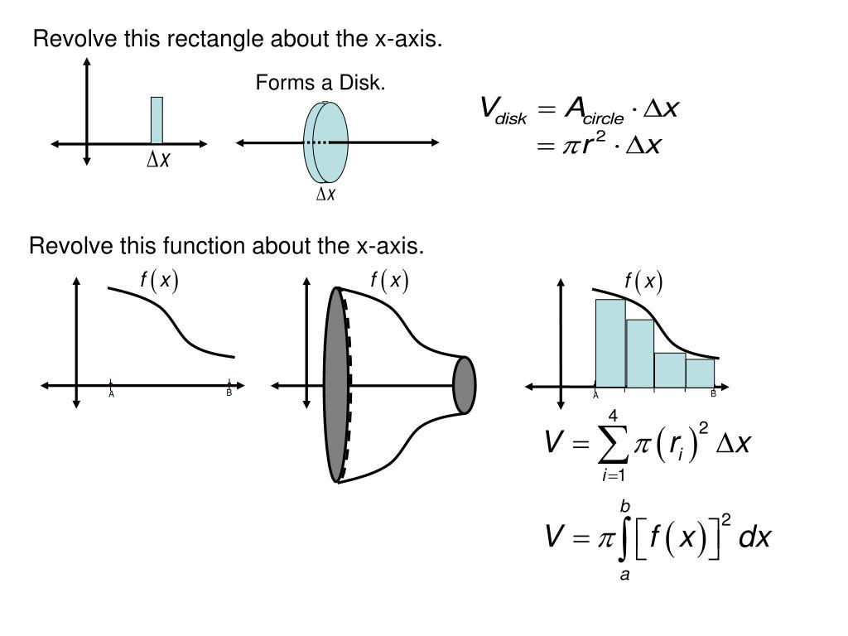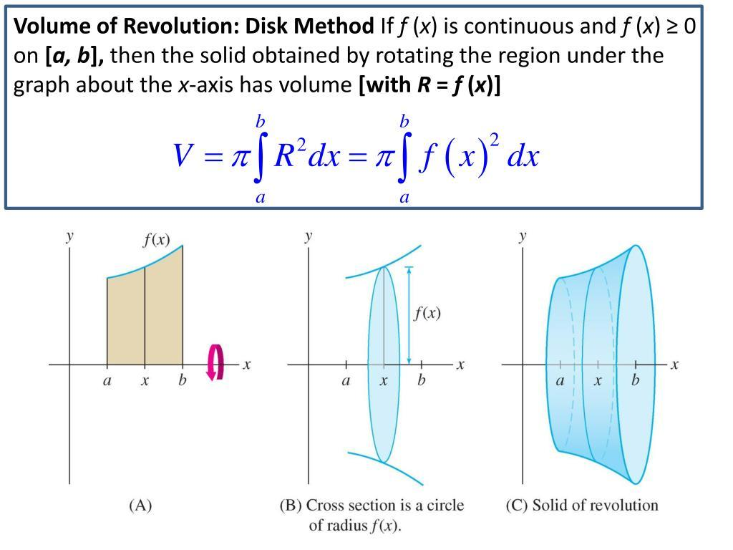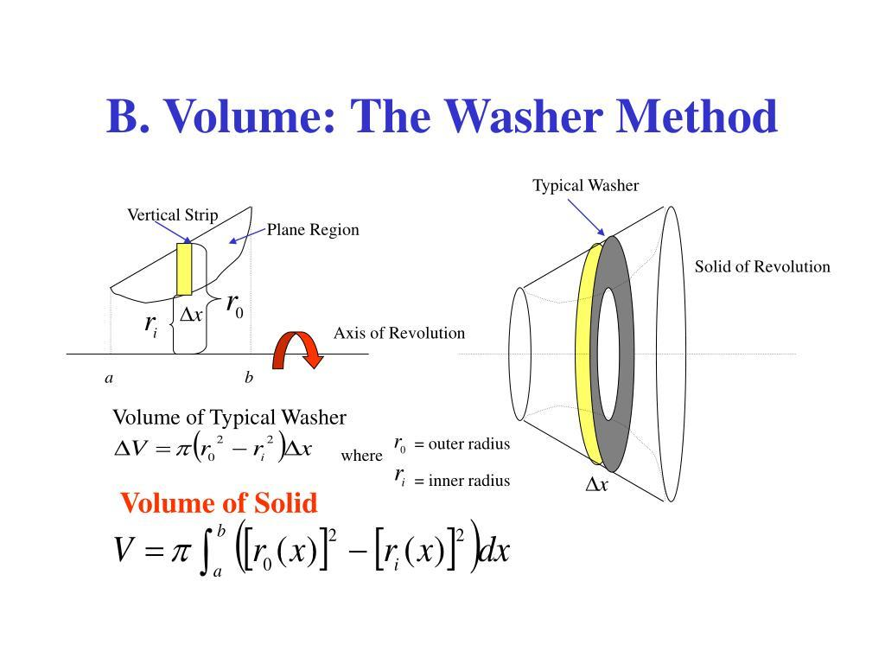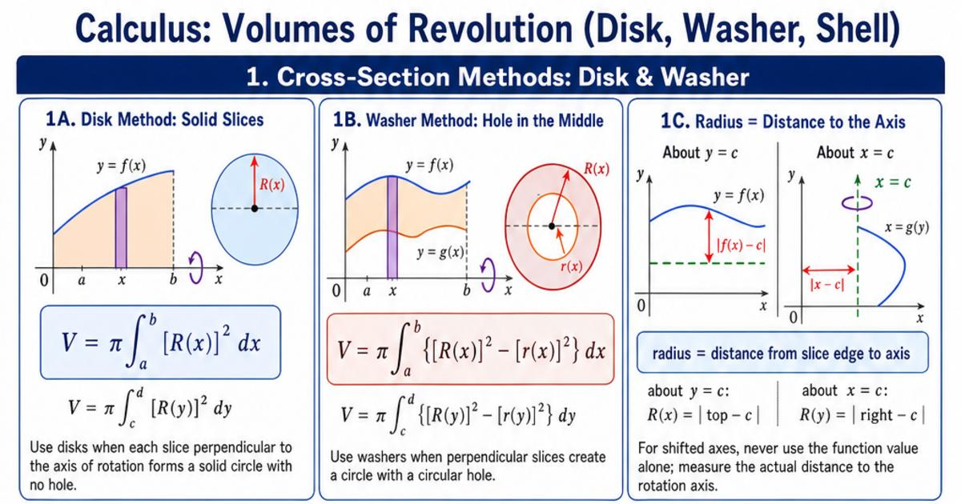
A Rotational Plane-Region Generator is a plane region that rotates around a fixed axis to generate a solid of revolution.
Examples:
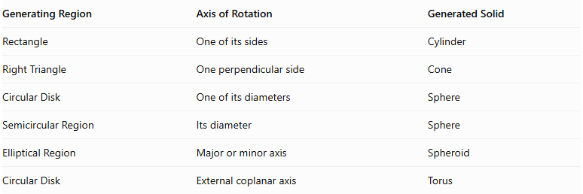
Generating Region | Axis of Rotation | Generated Solid
Rectangle | One of its sides | Cylinder
Right Triangle | One perpendicular side | Cone
Circular Disk | One of its diameters | Sphere
Semicircular Region | Its diameter | Sphere
Elliptical Region | Major or minor axis | Spheroid
Circular Disk | External coplanar axis | Torus

Translational Plane-Region Generator
# Source: AI Source: Provided by: [Data Path: Persons Table -> ID Column: 1, Name_En Column: Motasem Essam] -> From: [ChatGPT] on [7/25/2026]
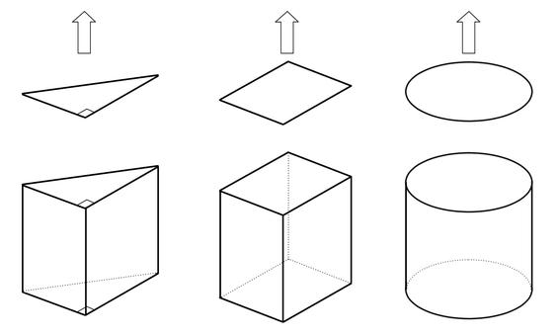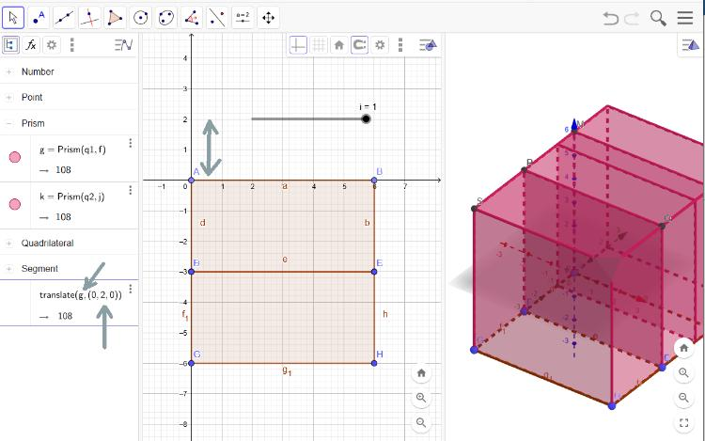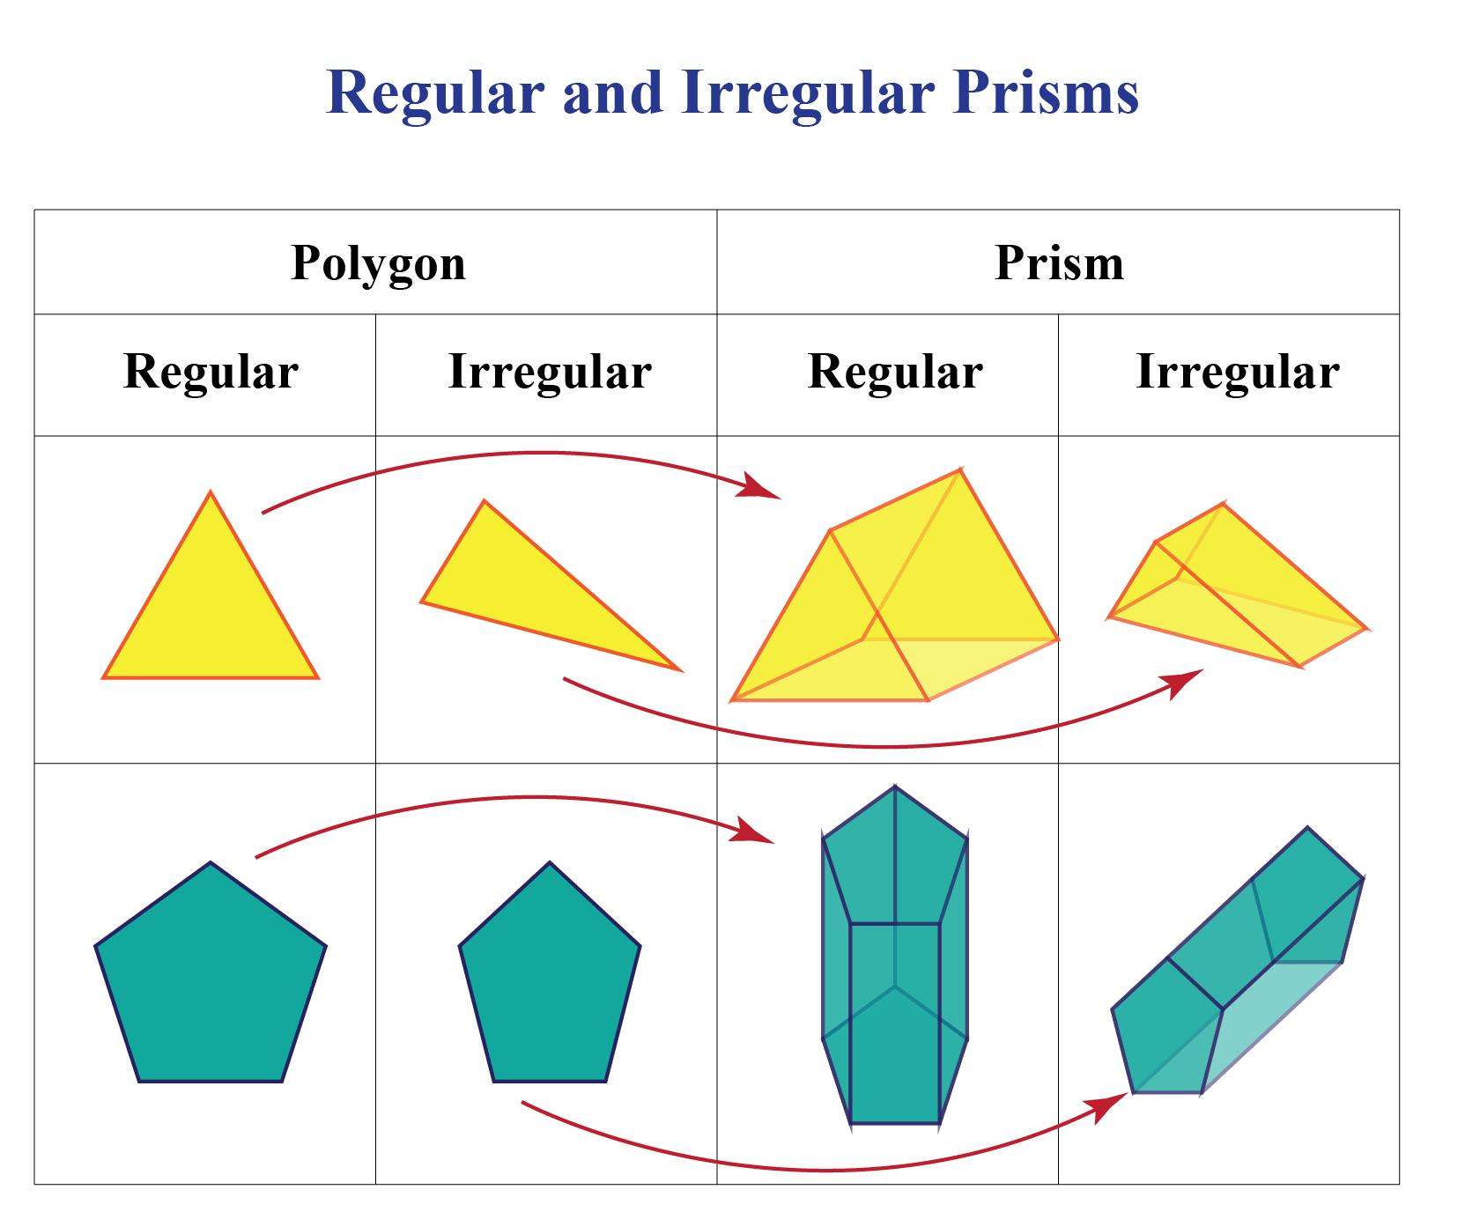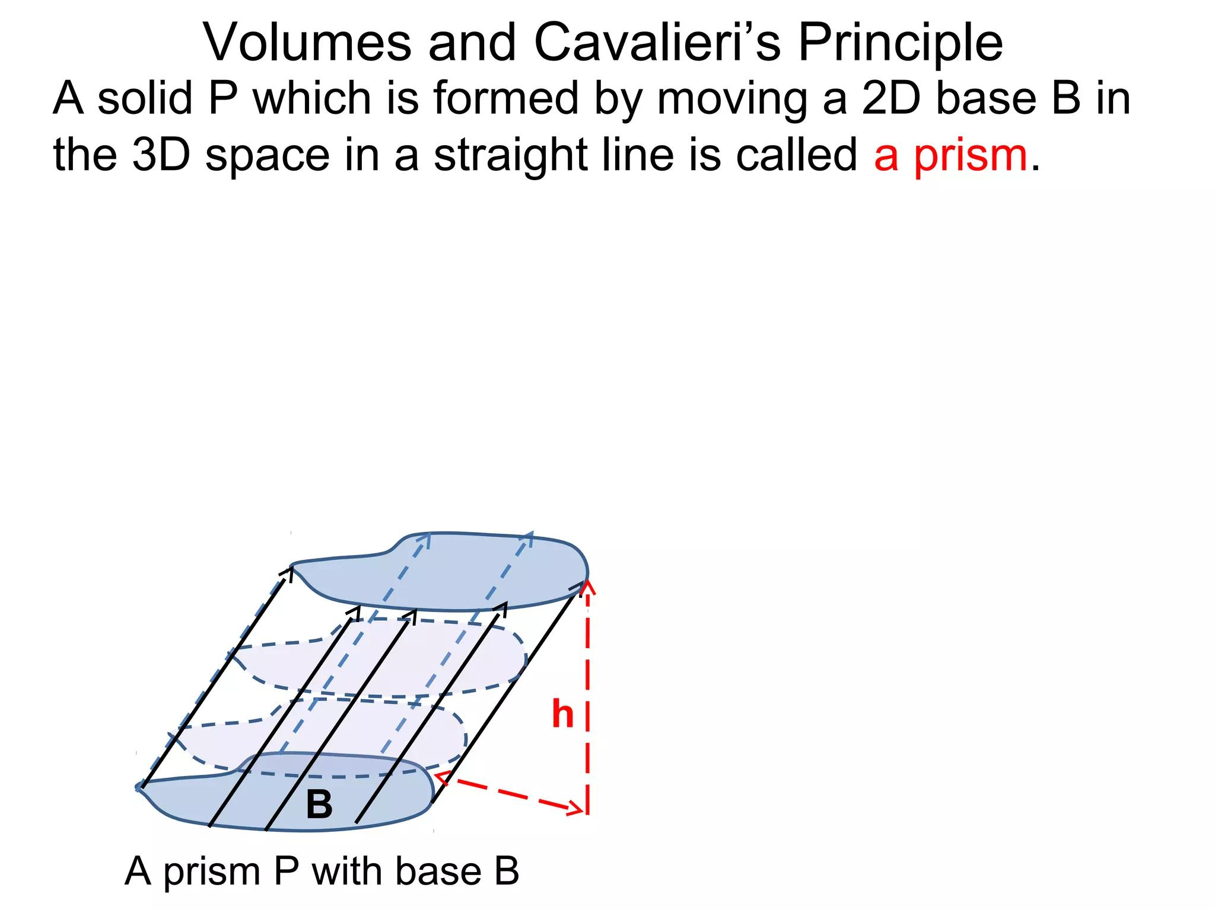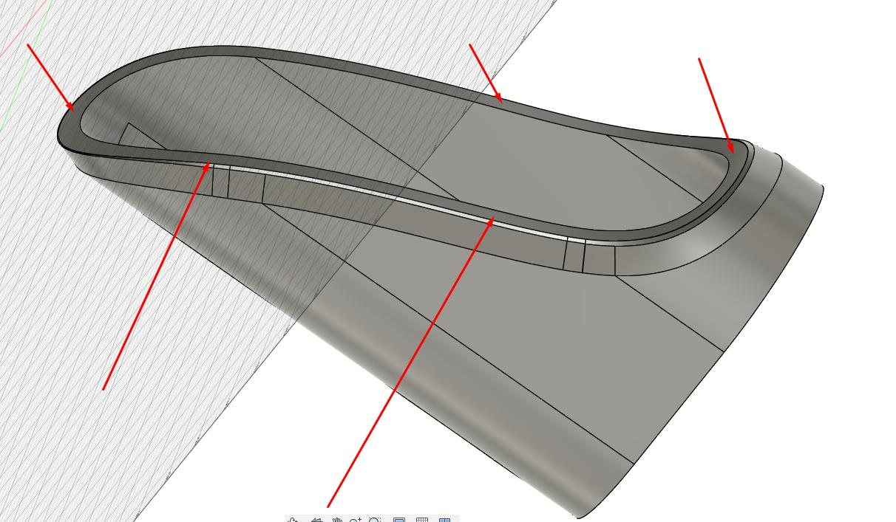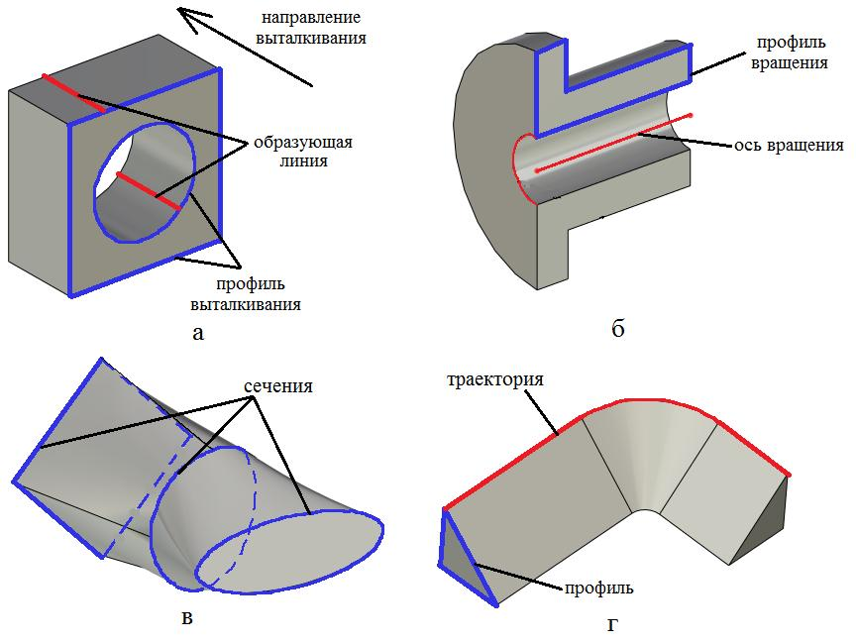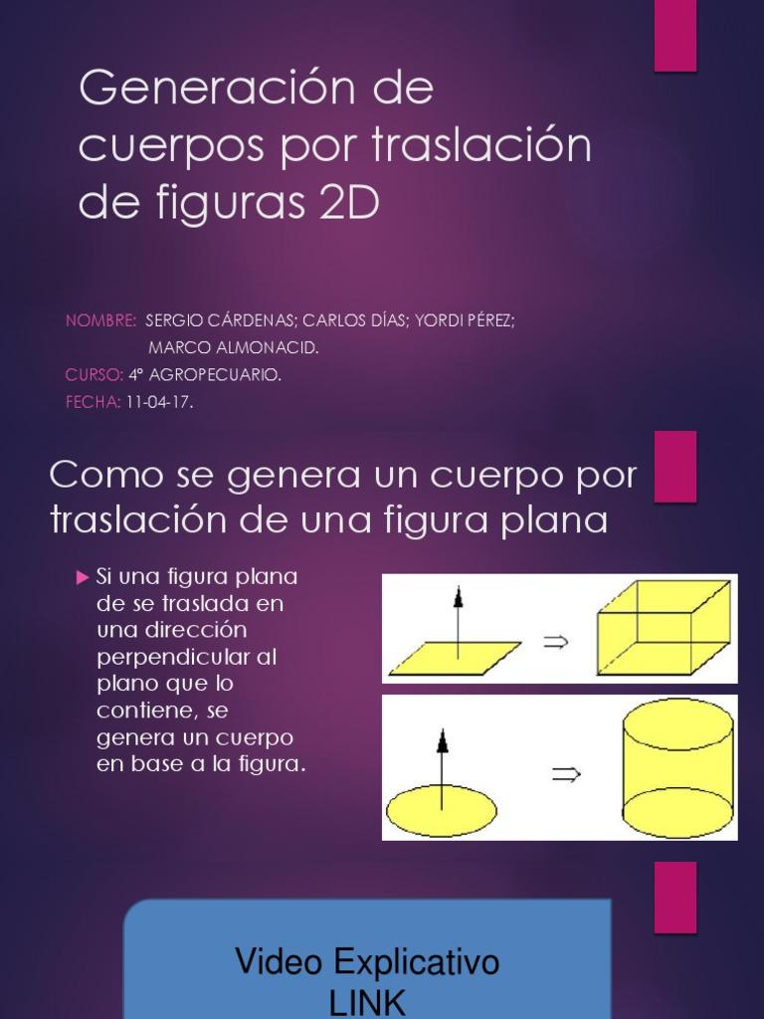
A Translational Plane-Region Generator is a plane region that moves along a specified direction without changing its shape or orientation.
Its movement generates an extruded solid.
Examples:
- Rectangle → Rectangular Prism.
- Triangle → Triangular Prism.
- Circle → Circular Cylinder.
- Ellipse → Elliptical Cylinder.
- Regular Polygon → Regular Prism.
- Irregular Polygon → Irregular Prism or Extruded Solid.

Combined-Motion Plane-Region Generator
# Source: AI Source: Provided by: [Data Path: Persons Table -> ID Column: 1, Name_En Column: Motasem Essam] -> From: [ChatGPT] on [7/25/2026]
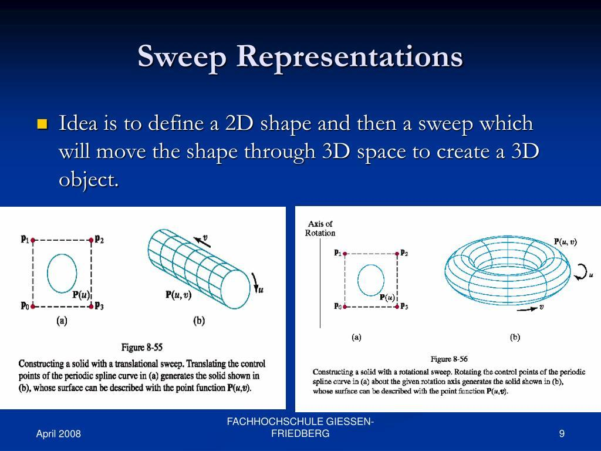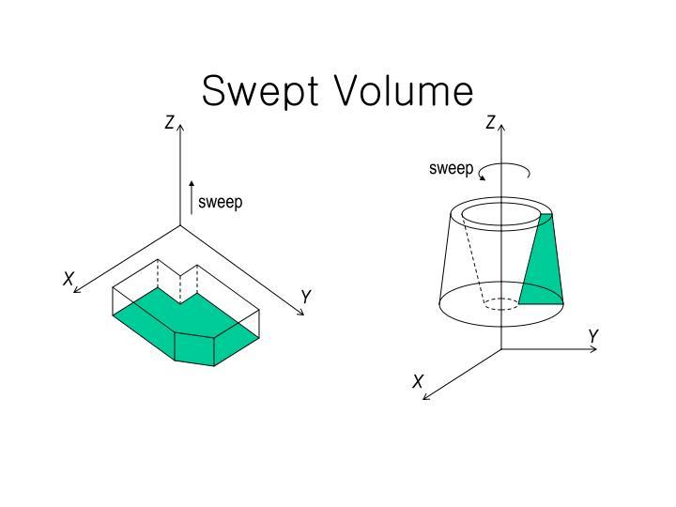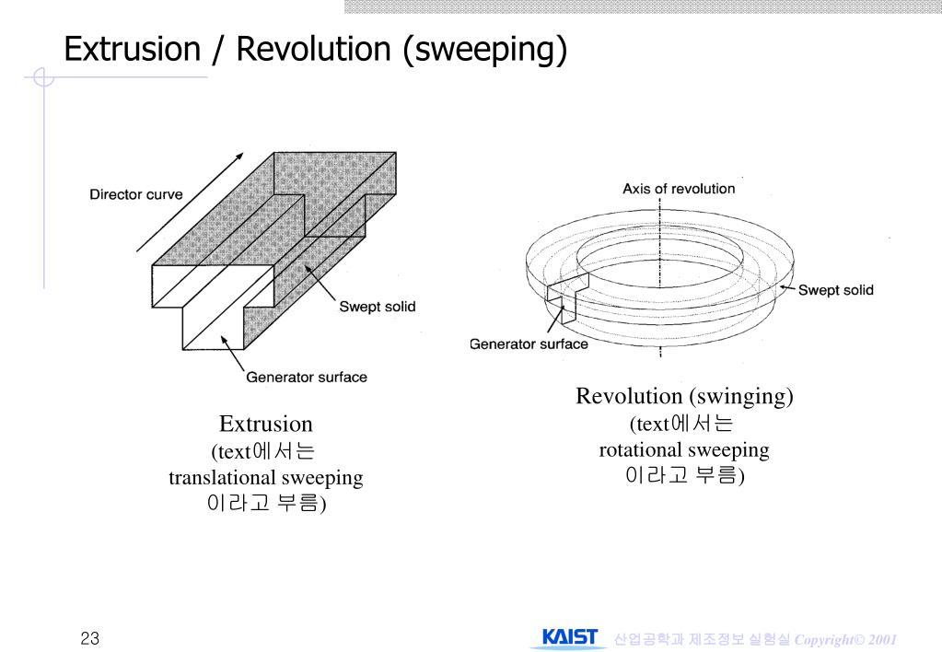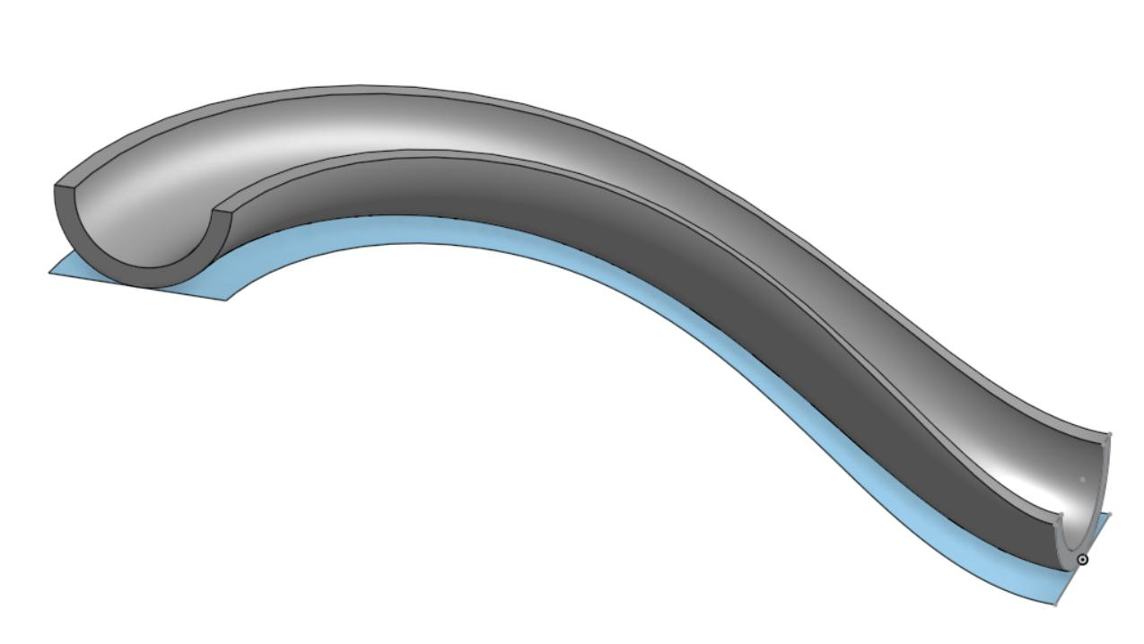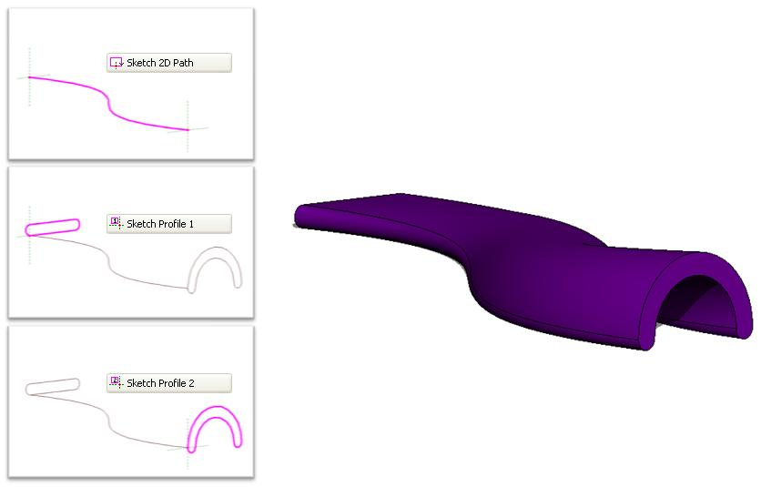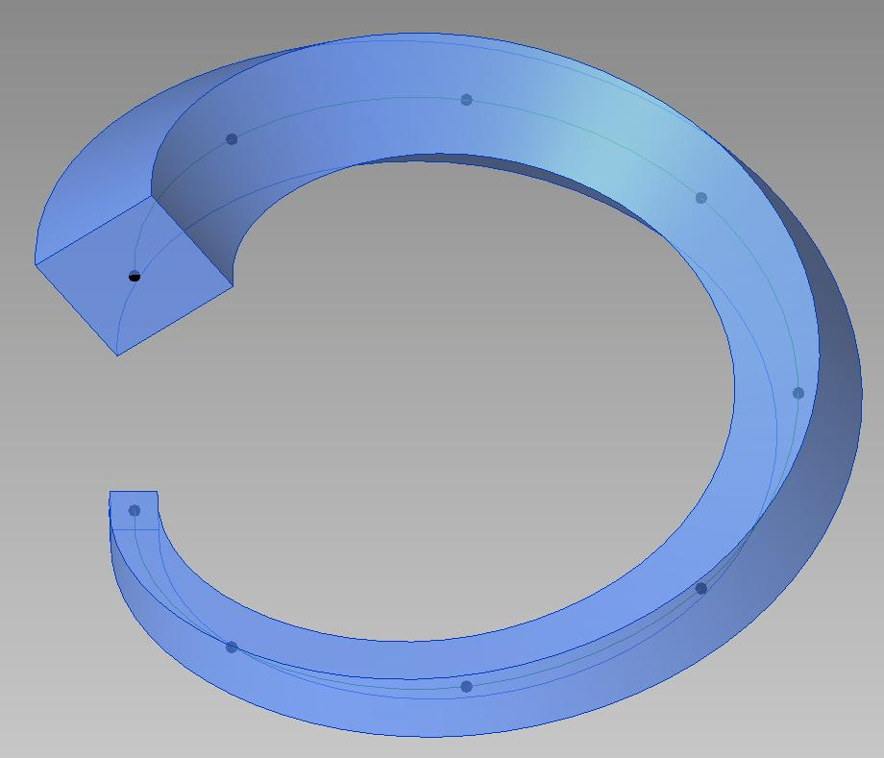
A Combined-Motion Plane-Region Generator is a plane region that undergoes two or more simultaneous or successive types of movement.
Examples:
- Rotational and Translational Motion: A region rotates while moving along a direction.
- Curved-Path Sweeping: A region moves along a curved trajectory.
- Variable-Orientation Sweeping: A region changes its orientation while moving along a path.
These movements can generate more complex swept solids.

Mathematical Representation
# Source: AI Source: Provided by: [Data Path: Persons Table -> ID Column: 1, Name_En Column: Motasem Essam] -> From: [ChatGPT] on [7/25/2026]
A plane-region generator can be represented as a two-dimensional region that moves through three-dimensional space.
Let the generating region be $R$, and let $T_{t}$ represent its position at a particular stage of motion.
The generated solid is the union of all positions occupied by the region:
$$\boxed{S=\bigcup_{t∈I}{T_{t}(R)}}$$
Where:
- $R$ = Original plane region.
- $T_{t}$ = Transformation describing its movement.
- $I$ = Interval of motion.
- $S$ = Generated three-dimensional solid.

Rotational Generation
# Source: AI Source: Provided by: [Data Path: Persons Table -> ID Column: 1, Name_En Column: Motasem Essam] -> From: [ChatGPT] on [7/25/2026]
When a plane region rotates around the $z$-axis, a point with coordinates $(r,z)$ traces a circular path.
The rotational transformation is:
$$\boxed{beginalignedx\&=rcosθ\backslash y\&=rsinθ\backslash z\&=zendaligned}$$
Where:
$$0≤θ≤2π$$
For a complete rotation, the region generates a solid of revolution.

Translational Generation
# Source: AI Source: Provided by: [Data Path: Persons Table -> ID Column: 1, Name_En Column: Motasem Essam] -> From: [ChatGPT] on [7/25/2026]
When a plane region translates along a fixed vector $d$, its position can be represented by:
$$\boxed{X(u,v,t)=R(u,v)+td}$$
Where:
- $R(u,v)$ represents points in the original region.
- $d$ represents the translation direction.
- $t$ represents the translation distance parameter.
When the region translates perpendicular to its plane, it generates a straight extrusion, such as a prism or cylinder.

Volume of Generated Solids

Volume of a Solid of Revolution
# Source: AI Source: Provided by: [Data Path: Persons Table -> ID Column: 1, Name_En Column: Motasem Essam] -> From: [ChatGPT] on [7/25/2026]
The volume of a solid generated by rotating a plane region can be calculated using integration.
Disk Method:
$$\boxed{V=π\int_{a}^{b}{[R(x)]^{2} dx}}$$
Washer Method:
$$\boxed{V=π\int_{a}^{b}{\left([R(x)]^{2}-[r(x)]^{2}\right)} dx}$$
Where:
- $R(x)$ = Outer radius.
- $r(x)$ = Inner radius.
- $a,b$ = Limits of integration.

Volume of a Translationally Generated Solid
# Source: AI Source: Provided by: [Data Path: Persons Table -> ID Column: 1, Name_En Column: Motasem Essam] -> From: [ChatGPT] on [7/25/2026]
For a plane region translated perpendicular to its plane through a distance $h$:
$$\boxed{V=Ah}$$
Where:
- $A$ = Area of the generating region.
- $h$ = Translation distance.
This formula applies to a straight extrusion with constant cross-section.

Pappus's Centroid Theorem
# Source: AI Source: Provided by: [Data Path: Persons Table -> ID Column: 1, Name_En Column: Motasem Essam] -> From: [ChatGPT] on [7/25/2026]
For a plane region rotated once around an external coplanar axis that does not intersect its interior, the volume of the generated solid is:
$$\boxed{V=2πbarrA}$$
Where:
- $A$ = Area of the generating region.
- $barr$ = Distance from the region's centroid to the axis of rotation.
- $2πbarr$ = Distance traveled by the centroid during one complete revolution.
This theorem provides an alternative method for calculating volumes of solids of revolution.

Comparison of Plane-Region Generator Types
# Source: AI Source: Provided by: [Data Path: Persons Table -> ID Column: 1, Name_En Column: Motasem Essam] -> From: [ChatGPT] on [7/25/2026]
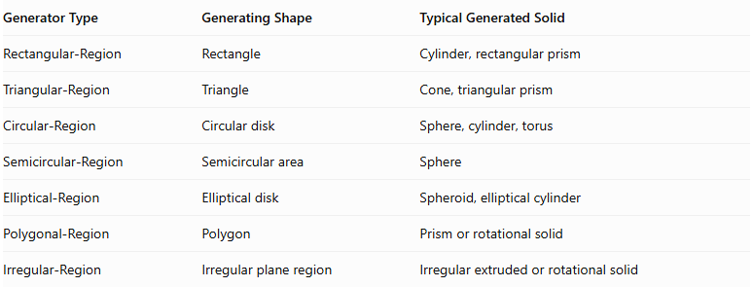
Generator Type | Generating Shape | Typical Generated Solid
Rectangular-Region | Rectangle | Cylinder, rectangular prism
Triangular-Region | Triangle | Cone, triangular prism
Circular-Region | Circular disk | Sphere, cylinder, torus
Semicircular-Region | Semicircular area | Sphere
Elliptical-Region | Elliptical disk | Spheroid, elliptical cylinder
Polygonal-Region | Polygon | Prism or rotational solid
Irregular-Region | Irregular plane region | Irregular extruded or rotational solid

Comparison with Other Generator Types
# Source: AI Source: Provided by: [Data Path: Persons Table -> ID Column: 1, Name_En Column: Motasem Essam] -> From: [ChatGPT] on [7/25/2026]
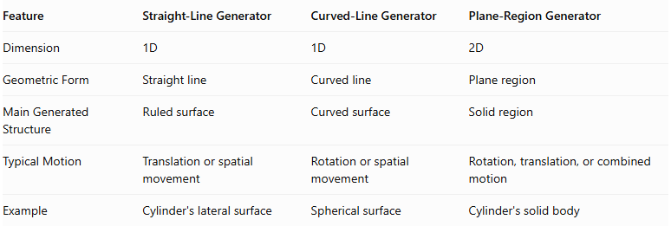
Feature | Straight-Line Generator | Curved-Line Generator | Plane-Region Generator
Dimension | $$1D$$ | $$1D$$ | $$2D$$
Geometric Form | Straight line | Curved line | Plane region
Main Generated Structure | Ruled surface | Curved surface | Solid region
Typical Motion | Translation or spatial movement | Rotation or spatial movement | Rotation, translation, or combined motion
Example | Cylinder's lateral surface | Spherical surface | Cylinder's solid body

Main Classification
# Source: AI Source: Provided by: [Data Path: Persons Table -> ID Column: 1, Name_En Column: Motasem Essam] -> From: [ChatGPT] on [7/25/2026]
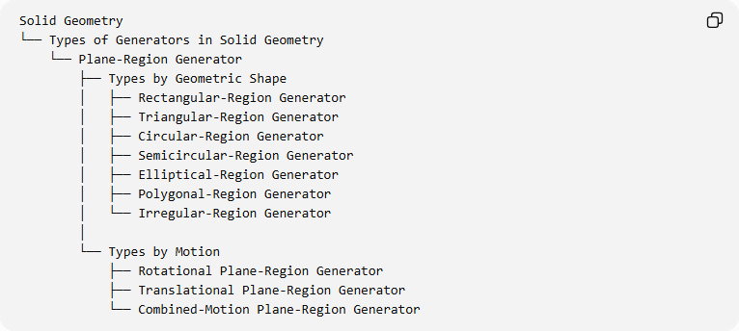
Solid Geometry
└── Types of Generators in Solid Geometry
└── Plane-Region Generator
├── Types by Geometric Shape
│ ├── Rectangular-Region Generator
│ ├── Triangular-Region Generator
│ ├── Circular-Region Generator
│ ├── Semicircular-Region Generator
│ ├── Elliptical-Region Generator
│ ├── Polygonal-Region Generator
│ └── Irregular-Region Generator
│
└── Types by Motion
├── Rotational Plane-Region Generator
├── Translational Plane-Region Generator
└── Combined-Motion Plane-Region Generator

Important Distinctions
# Source: AI Source: Provided by: [Data Path: Persons Table -> ID Column: 1, Name_En Column: Motasem Essam] -> From: [ChatGPT] on [7/25/2026]
- Plane-Region Generator vs. Curved-Line Generator: A plane-region generator is two-dimensional and sweeps out a volume, whereas a curved-line generator is one-dimensional and generally generates a surface.
- Rotation vs. Translation: Rotation produces solids of revolution, while translation produces extruded solids.
- Generating Region vs. Generated Solid: The generating region is the original two-dimensional figure; the generated solid is the three-dimensional result of its motion.
- Generating Shape vs. Motion Type: Rectangular, triangular, and circular describe the region's shape; rotational and translational describe how it moves.
- Complete vs. Partial Rotation: A complete revolution generally uses an angle of ${360}^{∘}$, while a partial revolution produces only a portion of the corresponding rotational solid.

Key Points
# Source: AI Source: Provided by: [Data Path: Persons Table -> ID Column: 1, Name_En Column: Motasem Essam] -> From: [ChatGPT] on [7/25/2026]
- A plane-region generator is a two-dimensional geometric region used to generate a solid.
- It can be rectangular, triangular, circular, semicircular, elliptical, polygonal, or irregular.
- It can generate solids through rotation, translation, or combined motion.
- Rotating a rectangle around one of its sides generates a cylinder.
- Rotating a right triangle around one of its perpendicular sides generates a cone.
- Rotating a circular disk around its diameter generates a sphere.
- Translating a polygon perpendicular to its plane generates a prism.
- The volume of a rotationally generated solid can be calculated using integration or Pappus's centroid theorem.

Conclusion
# Source: AI Source: Provided by: [Data Path: Persons Table -> ID Column: 1, Name_En Column: Motasem Essam] -> From: [ChatGPT] on [7/25/2026]
The Plane-Region Generator is a fundamental concept in solid geometry that describes how a two-dimensional geometric region produces a three-dimensional solid through motion. Its different shapes and movement types provide the geometric foundation for generating cylinders, cones, spheres, spheroids, prisms, tori, and many other solids.
References:
- OpenStax – Pappus's Theorem for Volume
- OpenStax – Volumes of Solids of Revolution
- Wolfram MathWorld – Pappus's Centroid Theorem

